Babushka and the Nomads

Dahlia couldn’t believe that she was missing Sarah’s birthday party for this. Sarah’s parents had rented the entire Splash Harbor Amusement Park and invited everyone in grade 12. It was going to be the party of the year, and Dahlia desperately wanted to go. Instead, she was stranded for the summer in Kyrgyzstan with only her babushka, Aidana, for company.

Dahlia stared forlornly out of the window of Aidana’s car, watching the Kyrgyzstan

countryside roll by. Had she not been so annoyed, Dahlia might have appreciated the

sprawling mountains and clear blue rivers they passed, but

she ignored the scenery completely.

Pulling out her phone, Dahlia opened the YouTube app. When the home page failed to load, her eyes flicked to the bars at the top of her screen. Zero reception. Dahlia groaned, and irritation flared in the pit of her stomach. Derek Yeon’s latest video was out, but she couldn’t watch it.

Derek Yeon was Dahlia’s favorite You Tuber. The 23-year-old aspiring journalist travelled the world documenting the lives of everyday people in a series called *Interesting Places*.

Yeon was very cool, had a wicked sense of humor and visited weird and beautiful places, but Dahlia wouldn’t be able to see his latest video because she was stuck in Kyrgyzstan.

“Stop pouting,” Aidana scolded.

Dahlia turned her gaze to her babushka. The stern woman was nothing like Dahlia’s Texan grandma, Rose, who always wore cowboy boots and a Stetson, was quick with a joke, and smiled easily. “I’m not pouting,” Dahlia said, sticking out her bottom lip.

“Yes, you are. You’ve been pouting since you stepped off that plane in Bishkek three days ago,” Aidana sighed. “I know that you don’t

want to be here, but it is important that you know about where you come from and learn about our culture.”

“I know where I come from,” Dahlia protested. “And we have plenty of culture back home.”

Aidana eyed Dahlia skeptically. “What do you know about Kyrgyzstan?”

“I know that it used to be part of the Soviet Union,” Dahlia answered. “I know that it’s a country in Asia bordered by Kazakhstan, Uzbekistan, Tajikistan, and China. I know that for some crazy reason, Dad wanted me to spend the summer here in the middle of nowhere when I could have been at Sarah’s birthday party!” She glanced back down at her phone. Still no service.

Aidana sighed again. “We’re not in the middle of nowhere, Dahlia. Look out the window.”

Dahlia looked up from her disconnected phone and focused her attention out the window. The countryside stretched out as far as Dahlia could see. Mountains rose up on either side of the car. The road followed a bright blue river which cut through the heart of the heavily forested valley. *Trees, trees and more trees*, thought Dahlia.

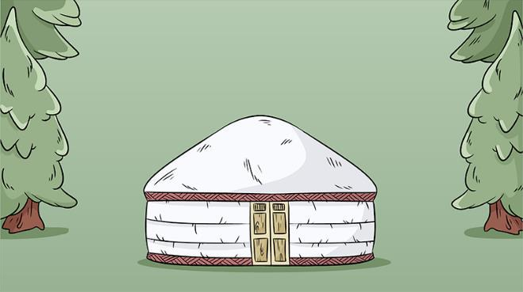A short time later, they came upon a village constructed of portable round tents known as yurts. People milled about the tents, some

dressed in traditional ethnic clothing while others wore t-shirts and jeans.

“What is this?” Dahlia asked.

“This is the World Nomad Games,”

Aidana informed her. “Think of it like the Olympics of Asia, but instead of running and jumping, it has sports that originated in Central Asia. The World Nomad Games started in 2014, and they have taken place every two years since then. It’s a celebration of the nomadic peoples from Mongolia to Turkey. People from all over the world come to compete in the events, even Americans.”

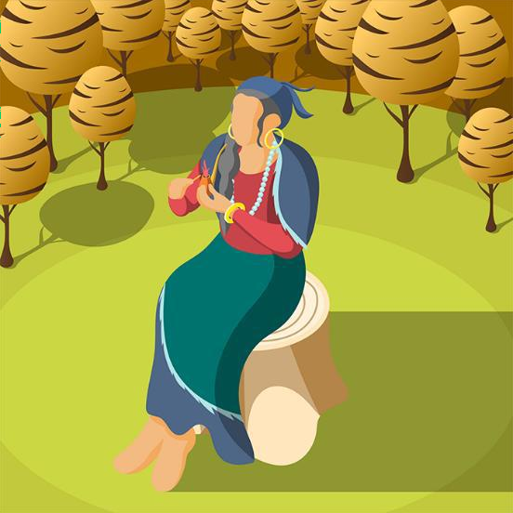Dahlia had never heard of the World Nomad Games. She watched as two young men in elaborate costumes passed in front of their car with huge birds, as big as eagles, perched on their arms. A girl her own age in a long red gown and a very tall hat rode by on a beautiful white horse, greeting the boys in some strange language as she passed them.

Aidana smiled at Dahlia’s surprised expression. “It’s interesting, I know,” Babushka said. “And it’s not only sports at the World Nomad Games. It is also a cultural festival.

The hosting country has the opportunity to share its culture with visitors. In the yurt village, you can listen to folk music and recitations of epic poems and legends, watch traditional dances, and see traditional clothing.”

After they had parked the car, Dahlia followed her babushka into the yurt village. All around them people were speaking languages from many countries. Babushka explained that people were speaking Chinese, Russian, Turkish, Korean, Mongolian, Arabic, Armenian, French, German, Spanish, and other languages, including English.

The scent of grilled meat filled Dahlia’s nose. Aidana stopped before a food vendor, buying them each a plateful of *kuurdak*, stewed mutton with onions and spices. Dahlia eyed the food suspiciously as they waited in line. She loved her dad’s homemade *kuurdak* , but she wasn’t sure she trusted food sold from a stall.

A voice from behind Dahlia inquired, “Have you had this before?”

“It’s *kuurdak*.” As she answered, Dahlia turned around and promptly froze. Standing directly behind her in all his glory was Derek Yeon, a video camera around his neck. Dahlia’s heart skipped a beat.

“You’re Derek Yeon.”

Derek smiled. “I am. I take it you’re familiar with my work.”

Dahlia was more than simply familiar with his work. She had watched every one of his videos multiple times. “I am.” It was the understatement of the century. “I’m Dahlia, and this is Aidana, my babushka. That means-”

“Grandmother,” Derek finished for her. “My Russian may be nonexistent, but I do know that word.” He went on to explain he was in Kyrgsztan filming an episode of *Interesting Places*. “The countryside is so beautiful here, and the culture is fascinating,” he enthused.

“Yes, it is so beautiful, and the culture is fantastic, too!” agreed Dahlia, avoiding her babushka’s skeptical gaze. “I could be your translator, if you like,” Dahlia offered. “I speak both Kyrgyz and Russian.”

“You’d really do that?” Derek asked, surprised.

“As long as it’s okay with Aidana.” Dahlia turned to Aidana, who was watching the exchange with trepidation. “Can I?”

“No,” Aidana said. “I promised your parents I would look after you, and I am not about to let you go wandering off with this young man.” Dahlia felt her heart sink. “However, he can join both of us if he wants a tour guide.”

Holding her breath, Dahlia waited for Derek’s answer. She doubted a cool You Tube journalist would want to spend his time with her and her babushka, but Derek immediately nodded. “It sounds like fun. Do you mind if I film you guys?”

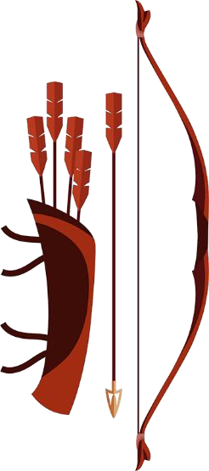“No,” Dahlia answered for Aidana. “I mean, go right ahead. It’s totally fine.” Derek powered up his camera and set about filming as Dahlia and Aidana ate their lunch. He mostly interviewed Aidana about local life; Dahlia slid a little closer to her grandmother.

“Let’s go check out some of the games,” Aidana suggested as she finished her lunch and disposed of their trash.

They followed the crowd out of the yurt village to the edge of camp, where an archery range was set up. Instead of the round targets that Dahlia was used to seeing in American movies, the targets were pear -shaped, bigger on the bottom than they were on the top.

“Because there are so many different countries participating in the World Nomad Games, there are five different types of archery,” Aidana explained to Dahlia and Derek. “This is traditional Kyrgyz archery. There are four women and four men on each team. They are required to wear traditional dress when competing and are only allowed to use wooden bows and arrows.”

With Derek beside her, it was easy to get swept up in the games. A woman pulled back a curved bow with the fluidity of an expert, shot an arrow at the target, and cheered as it hit home. Excitement bubbled in Dahlia’s chest. She couldn’t wait to watch this episode of *Interesting Places*.

They spent the afternoon moving from event to event, with Dahlia helping Derek interview various people. Then, one of the local archers, a 20-year-old Kyrg named Umar, took them for a drive through the countryside. Dahlia filled her camera with shots of stunning landscapes while Derek filmed.

When they returned, Umar invited them all to a “Nomad party” that was happening that night.

“What’s a Nomad party?” Derek asked.

“A big group of us get together and wander around all night, sort of

like nomads,” laughed Umar. “We bring food and drink and sing songs and just keep walking. It’s a lot of fun.”

“I’m in!” replied Derek.

“Me, too!” exclaimed Dahlia.

“No chance!” said Aidana, taking Dahlia’s hand. “We are not nomads! We have a house and we’re going home.” She gave Derek and Umar big hugs, wished the boys well and marched Dahlia back to their car.

As for Dahlia, she had long forgotten about her friend’s birthday party. She marveled at the countryside on the drive home and looked forward to meeting more Kyrgyz and learning more about their culture. Maybe she would make some videos of her own.

